Resource 6.1: King John speech bubble
I cannot believe that Magna Carta is STILL remembered! When I sealed it back in June 1215 I thought that it would be forgotten within months. In fact I did everything I could to make sure it was. Back then it seemed that Magna Carta WOULD be forgotten because…
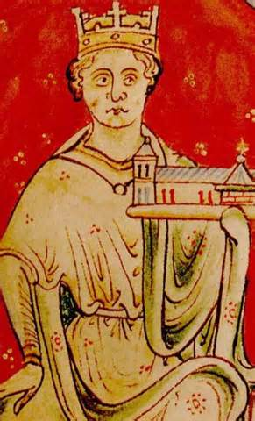

Resource 6.2 Table: data capture
Big reason | Examples that support this | This helped make sure Magna Carta was not forgotten because…
King John’s bad reputation
- John’s bad decisions
The radical ideas in the charter
- Ideas it set out
- Groups of people it applied to
- The idea of a charter
The revival of the charter
- Actions of the kings
- Actions of the barons
- Actions of the church
- Luck
The reinvention of the charter
- By the king
- By the barons

Without the charter’s radical ideas, it would have been forgotten. After all, kings had signed charters before and we don’t talk much about them any more! It was because of the ideas in the charter that later kings and barons kept coming back to it.
Without King John’s ‘bad’ reputation, Magna Carta would never have been needed, let alone survived!! John’s bad reputation helped make sure it was not forgotten – it was fear that future kings might behave like John that made the barons determined to use it to limit the king’s power.

Without the charter’s reinvention in the century following its creation, it would eventually have been forgotten. It was only because it was used by both kings and barons that it became a symbol of law and freedom for the people.
Without the charter’s revival in the year following its signing, it would almost certainly have been forgotten! If John hadn’t died, Henry III would never have become king and there would have been no one to reissue the charter.

