Resource 1.1: Henry I’s nightmares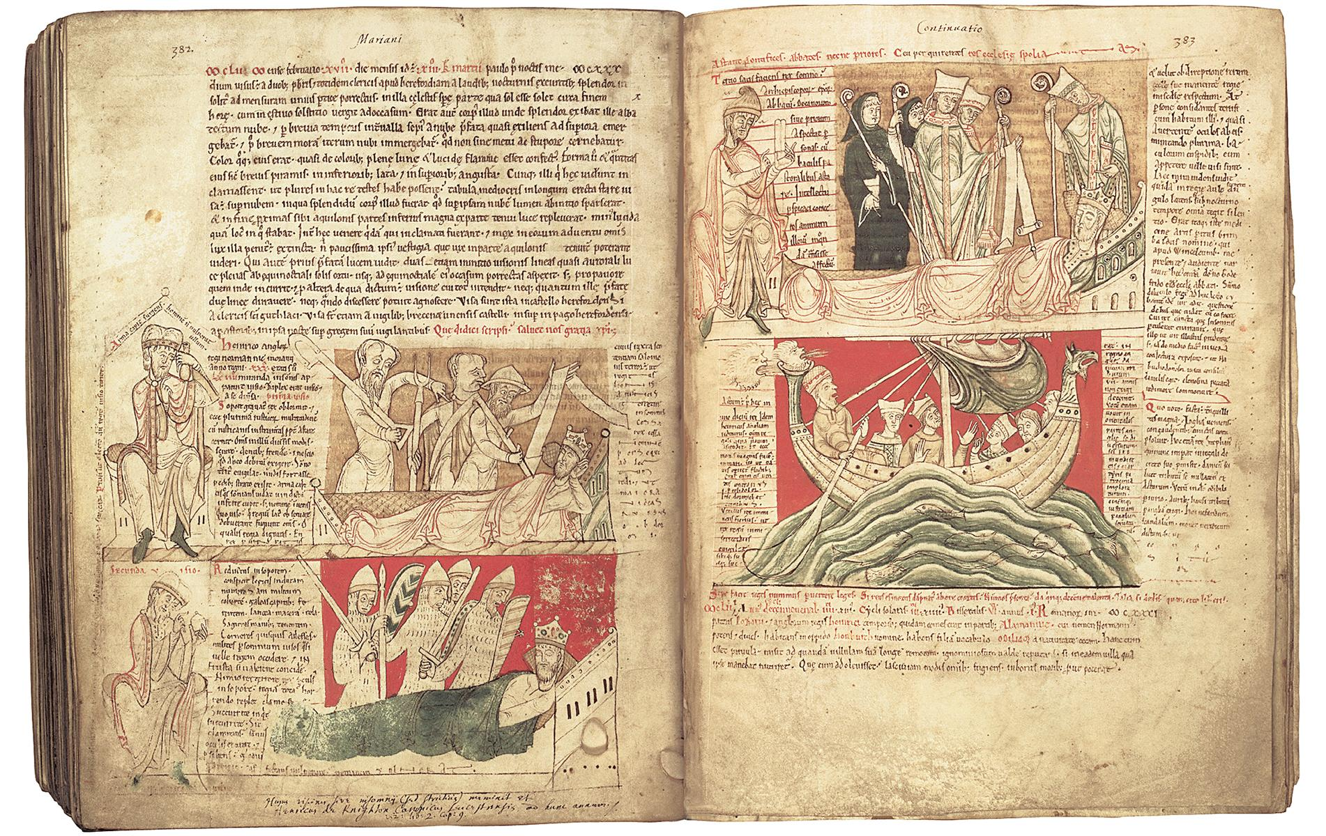
Each picture shows King Henry I. What do you notice about:
- Where he is and what he is doing?
- Who is with him?
What do you think the pictures are showing?

Resource 1.2a The terms of King Henry I’s coronation charter

- 1. When an archbishop or bishop or abbot dies I will not take anything from the church's land or from its men until a new archbishop or bishop or abbot is appointed.
- 2. If any of my barons or earls dies, his heir shall not have to buy back his land from me as they used to do when my brother was king. But he shall pay a fair and lawful relief [tax].
- 8. If any of my barons or men commits a crime, he shall not have to make a payment to the king as my father or my brother made them do. But he shall have to put things right according to how serious the crime is, as he would have done before the time of my father.
- 11. To those knights who give me military service in return for their lands I grant that their lands be free from all payments and all work. This means they can equip themselves well with horses and arms and be fully prepared to help me defend my kingdom.

Key words:
heir a person who gets the land and property of someone who has died
relief a tax (money paid to the king)
arms weapons

Task
Colour-code anything that suggests that the charter was concerned with:
money land law and order

Colour-code in a different colour to whom the terms applied:
the barons the church the knights

Resource 1.2b The terms of King Henry I’s coronation charter (access)

- 1. When an important churchman dies I will not take anything from the church until a new person is given the job.
- 2. If any of my barons dies, his heir shall not have to buy back his land from me. But he shall pay a fair and legal tax.
- 8. If any of my barons or men commits a crime, he shall not have to make a payment to the king. But he shall have to put things right, as he would have done before the time of my father.
- 11. Knights who give me military service in return for their lands will not also have to pay tax or provide work. This means they can make sure they have enough horses and weapons to help me defend my kingdom.

Key words:
heir a person who gets the land and property of someone who has died
relief a tax (money paid to the king)
arms weapons

Task
Colour-code anything that suggests that the charter was concerned with:
money land law and order

Colour0code in a different colour to whom the terms applied:
the barons the church the knights

Resource 1.3 Information cards: three kings

Henry I
King Henry I reigned from 1133 to 1189. Henry spent the first years of his reign fighting his brother, Robert, for control of their lands in Normandy, France. But fighting wars cost a lot of money. Henry had to increase taxes and force many of his barons to fight in his army. With all of these expenses to deal with, Henry set up a new government office, called the Exchequer. It allowed Henry to track which barons had not paid the taxes and other fees that they owed the king. Henry then used the law to force them to pay. The barons were unhappy about paying higher taxes and fines.

Henry also created new courts that travelled around the kingdom. Crimes like murder and theft were now punished by hanging, or by cutting off people’s hands, while barons who broke the law were heavily fined or had their lands taken away. It was very unusual for the government to get involved in local law and order and many people were angry that the king was interfering in their lives.

The barons were particularly angry. They felt that Henry had more control over them than any previous king. They also realised that England was better run than it had ever been before, however, and that this made their lives easier. In fact, after Henry’s death many barons looked back fondly at his reign and said that England had never been so well ruled as under Henry I.

Henry II
Henry II’s mother, Matilda, was meant to become queen after her father, Henry I, had died, but her cousin, Stephen, got himself crowned first. The two of them then spent the next 20 years fighting for the crown! As a result, when Henry II became king the country was in a mess. The government and the law were often ignored. To deal with this, Henry introduced a new legal system. Like Henry I, he also brought back harsh punishments.

Besides England, Henry II ruled half of France. This huge empire was incredibly expensive to run so Henry had to raise lots of new taxes from his barons. He also used his new laws to fine them. If they did something wrong Henry II even threatened to take away their lands. Many barons hated these new laws and new taxes. Henry faced lots of rebellions, even from his own sons!

Henry also had a huge fight with the Archbishop of Canterbury, Thomas Becket. Becket was the most important man in the English church. Henry wanted his new laws to apply to the church too. He wanted to punish priests as he could peasants and barons, but Becket refused to agree. The quarrel became so bad that in 1170 a group of knights murdered the archbishop, thinking it would please the king. Henry was horrified. In 1174 he walked to Canterbury barefoot and was whipped by the monks to say sorry for his sins.

Richard I
Richard I became king in 1189 after the death of his father, Henry II. Like Henry, Richard ruled half of France as well as England. He spent most of his reign fighting the French king to keep control of his French lands. This was incredibly expensive, particularly because Richard built lots of new castles. To pay for it all he taxed his barons more heavily than any king had ever done before.

In 1187 the Muslim leader, Saladin, had captured the holy city of Jerusalem. Richard swore to go on crusade to re-take it. Once he became king, Richard decided that England should help to pay for his crusade, so he raised special ‘Saladin taxes’ and made people pay huge sums of money for the government jobs they did. He also sold lots of new rights to towns and cities. He is even supposed to have said ‘I would have sold London if I could find a buyer’! While Richard was on crusade he left his chancellor, William Longchamp, in charge. Longchamp was even harsher than Richard had been. He was hated by many barons. Richard’s brother, John, started to plot with the French king to steal the English throne.

Eventually, in 1192 Richard was forced to return to England. But he was captured on the way home and handed over to his enemy, the emperor of Germany. The emperor made Richard pay a huge ransom of 150,000 marks for his freedom. This was more than twice the total amount of money Richard received in a year! To get the ransom money everyone in England had to pay one quarter of the value of all their property. Gold and silver was even taken from churches and taxes were raised again. Then, when Richard finally returned home, he found that many of his lands in France had been conquered. To raise more money to win them back, Richard took back the lands, offices and rights that he had sold to pay for his crusade, and forced people to pay for them all over again!

Resource 1. 4: Living graph on medieval kings

Obeys all the rules

Rule breaker!
Henry I
Henry II

Resource 1.5 A picture of King John sealing Magna Carta
